621 Final Exam

**Submitted by:**

**Saeed Rahman**

# QuestionA

# QuestionB

# QuestionC

## Computing the Implied Volatility

Used Newton-Raphson Method

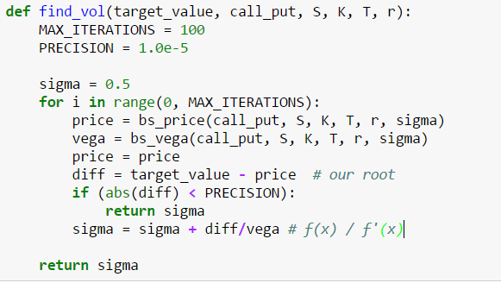

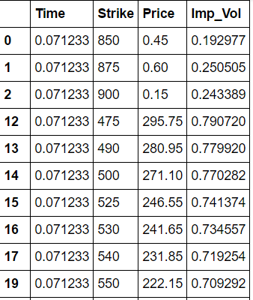

## Interpolating the Implied volatility Surface

Package Used: Scipy: Interpolate - interpolate.interp2d

Method: Cubic Spline

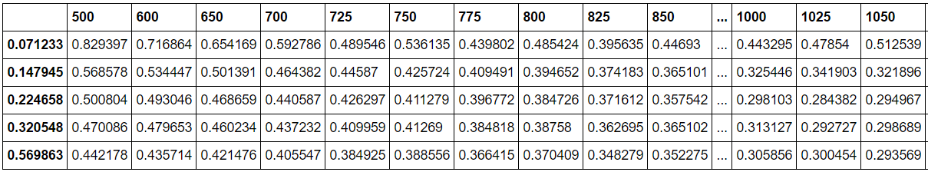

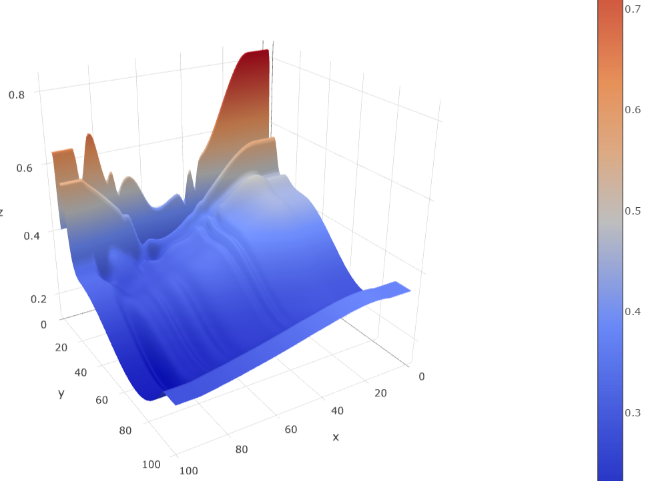

## C)

The no-arbitrage condition is not holding for all the points on the surface. As we can see, there are considerable dips and negative slopes in localized strike regions which could be potential arbitrage areas.

## D) Local Volatility

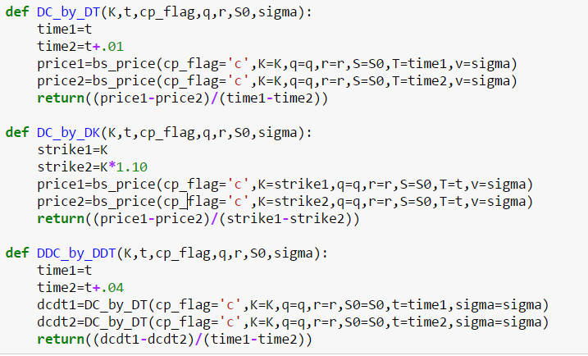

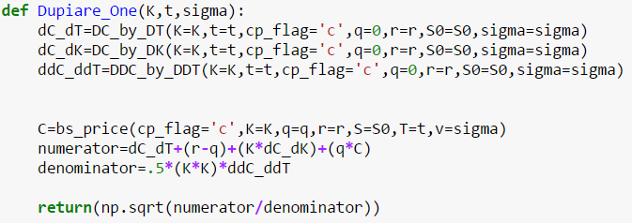

### Interpolated Dupire Local Volatility Grid

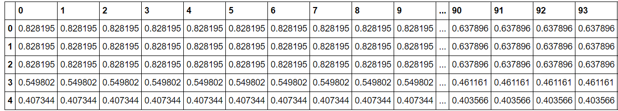

### Plot of Interpolated Dupire Volatility

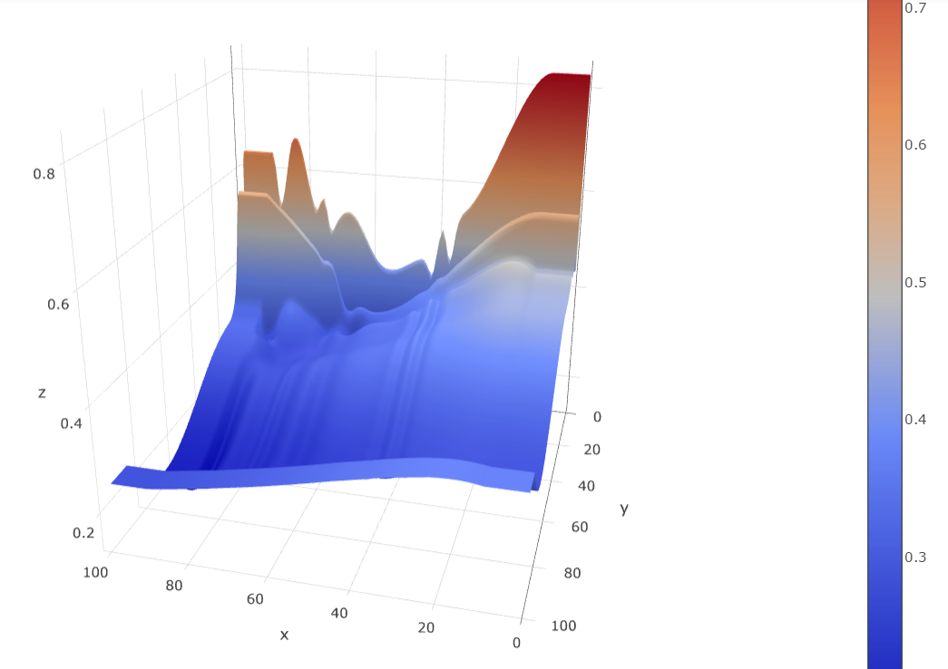

## E) Price of Option with Local Volatility

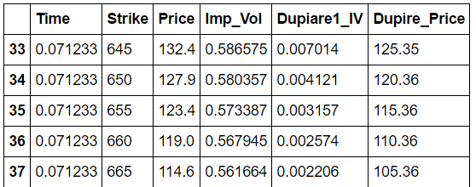

We can see that the Dupire price is less than the market price most of the times because we are taking the local volatility and local volatility is one that treats volatility as a function of both the current asset level and of time. As such, a local volatility model is a generalization of the Black-Scholes model, where the volatility is a constant. Because the only source of randomness is the stock price, local volatility models are easy to calibrate. Also, they lead to complete markets where hedging can be based only on the underlying asset. Since in local volatility models the volatility is a deterministic function of the random stock price, local volatility models are not very well used to price options whose values depend specifically on the random nature of volatility itself.

Therefore, Dupire option price is based on the underlying price volatility which is much lesser than the implied volatility and therefore the price calculated using Dupire volatility is less than the real price which is dependent on the implied volatility.

## F) Compiling all data into one table

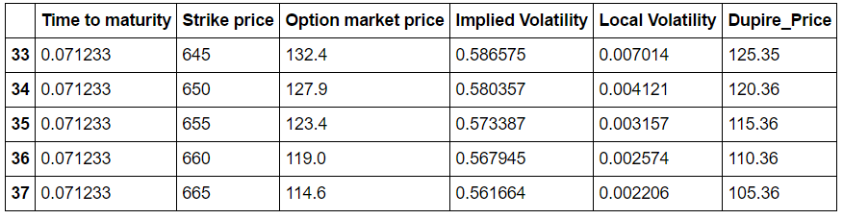

### "SPXvolatility.csv"

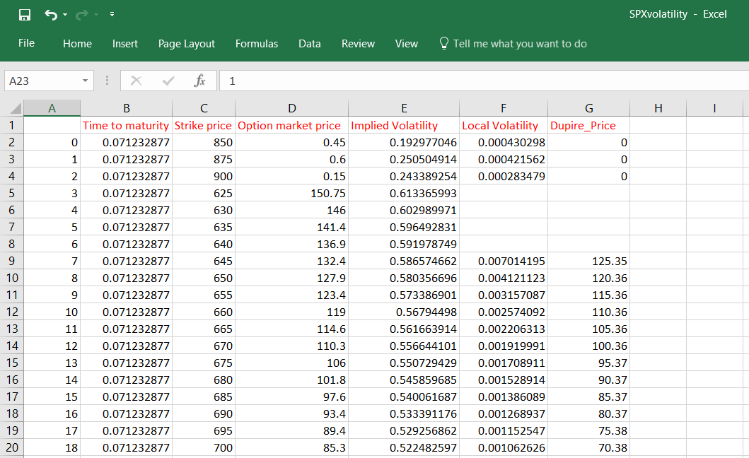

## G) Creating a custom function and Using External Data

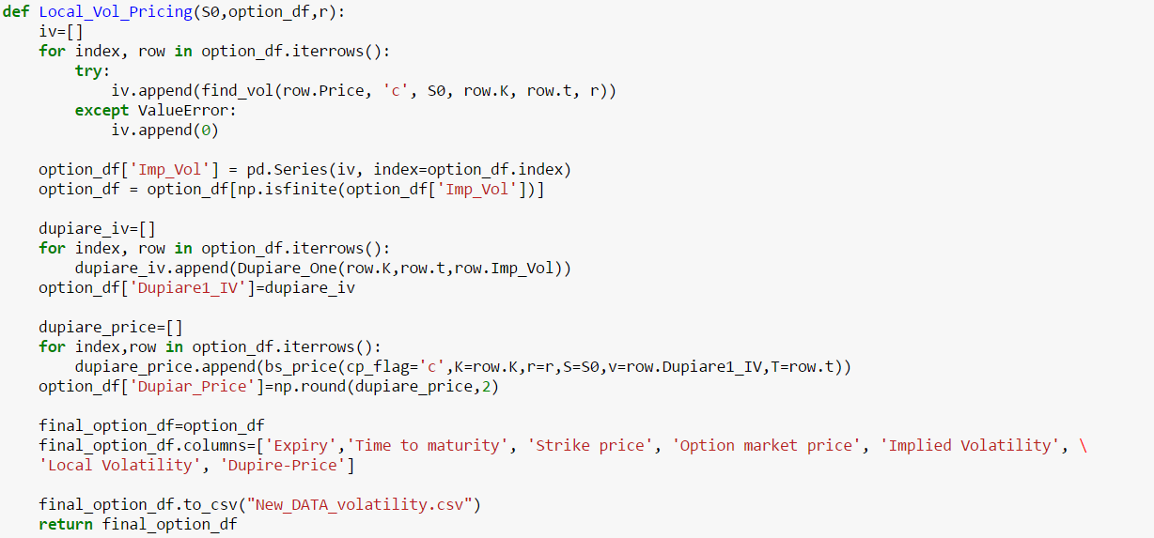

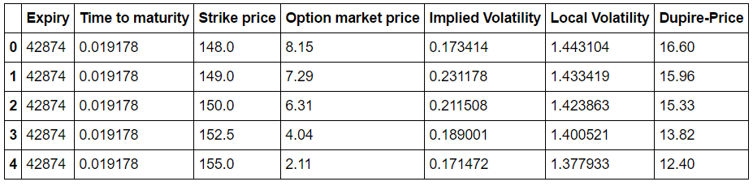

### Implementation Guide

File Name: **QuestionC_PartG.py**

Code design: Python3.6

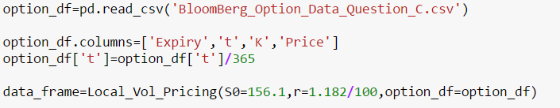

## Appendix: The code for this question (including the jupyter notebook and the HTML files) are in the QuestionC Folder